Task 1: Running Shellcode:

Prior to compilling, I disabled Address Space Randomization. Random address sorting selects the first address of the bulk and stack. This is done randomly can make guessing addresses directly difficult.

Then I compiled the call shellcode using the following gcc command. I also used the execstack option, which allows code to be generated from stack.

The result and source code are shown below:

Observation: The statement ((void(*)( ))buf)() in the main function of the code will invoke a shell, because the shellcode is executed.

Explanation:
(1) We can push the string “/bin/sh” onto stack, and then use the stack pointer esp to get the location of the string.
(2) We can convert the instructions that contain 0 into another instructions that do not contain 0. For example, to store 0 to a register, we can use XOR operation, instead of directly assigning 0 to that register.

Task 2: Exploiting the Vulnerability:

Above is the vulnerable program’s code. The buffer overflow is that In main(), we read up to 517 characters from the “badfile” and then copy them using function bof into a buffer that is 24. In this case, we overflow the buffer array in bof() since strcpy() does not check if the buffer can hold the what is copying. We use this copying outside the buffer to insert our code into the overflow area allowing us to get a shell to attack the program.

As shown above, I switched user to root and compile the vulnerable program. When compiling I use the flag “-fno-stack-protector” to disable GCC’s StackGuard which prevents buffer overflows. After compiling I used chmod to set-root-uid so that the program will run as root and when we get a shell we will have access to a root shell.

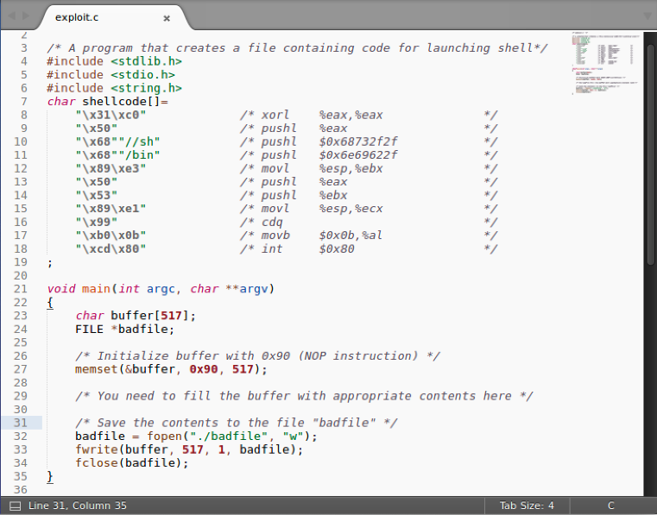

The exploit.c code is shown above, which will be placed at the end of the stack when the implementation of the exploit is finished. In main(), the buffer has the same size as the overflow in the vulnerable program and the file pointer that will create the “badfile”.
Then I set the buffer to be filled with NOP instructions, which when executed will do nothing and move to the next one.

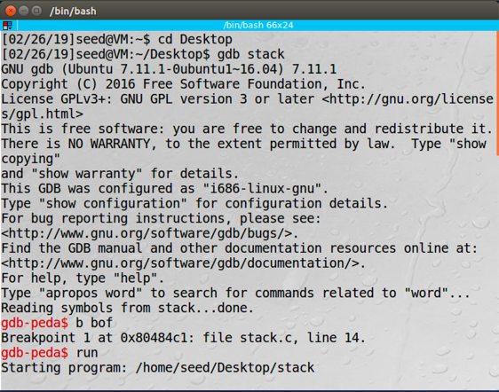
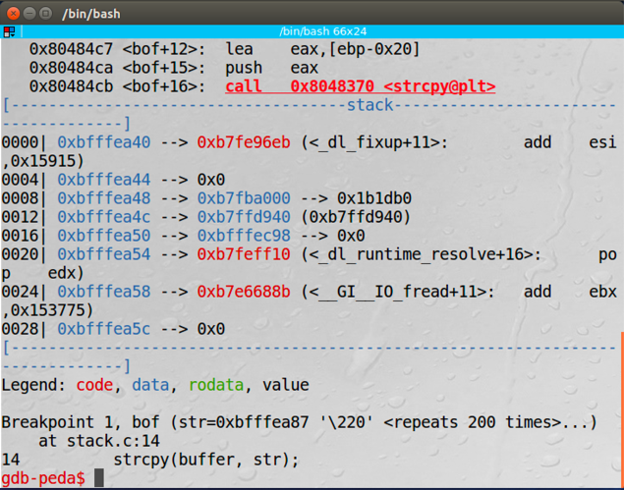
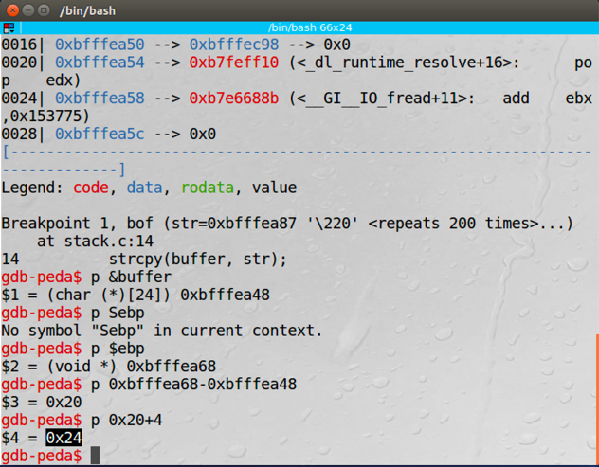

As shown above:
We need to find the location of the return address and the location of our bar to calculate the distance from the respondent to the return address. We use gdb to find both places. We start the gdb by having the conflict become our most manageable and put a crack in the job “bof” using “b bof”. Next, we use "run" to run the program to our rest area where we print ebp and buffer memory locations using "p $ ebp" and "p & buffer". The return address is 4 bytes above ebp so we calculate how far you are in the bar with this equation: (ebp address + 4) - (buffer address). In our system this range is 0x24 = 36.

We also need a stackpointer location where the vulnerable system overflows. To find this location I used dmesg and tail, as shown below, which prints on the board the value of our stackpointer when the program section is faulty. This value is required as this location, or sometimes after it, will be the location of our Shellcode to which we want to change the return address.

Now we have information we need to finish the exploit.c code. First, set the return address to our shellcode; Second, write the shellcode to the stack.

To set the return address we use the address of the start of the buffer and add the value we calculated earlier using gdb, which is 36, to create a pointer to that memory location and set it to the stack location we found added to some number. In this line we are overwriting the location address in the vulnerable program, stack.c, so that it points to the stack, or the overflowed area, so we can run the code we are going to insert.

Next, we use memcpy to copy the shellcode to the end of the buffer. We want to copy the shellcode to the end of the buffer as it increases the chances of our exploit working. It is because we fill the buffer originally with NOP instructions so if we use a return address that is a bit off, but before the shellcode, all of the NOPs will be run then our shellcode since NOPs do nothing and move on to the next instruction.

In the above image is my code. This buffer overflow vulnerability happened because the vulnerable program, stack.c, used a vulnerable C function, strcpy, to copy data from a file that is editable by the user allowing the user to insert machine code instructions into the file to be copied to memory in stack.c. The data in the file was able to be read into memory past the allocated size of the buffer it was to be copied into, because strcpy does not check if it will fit, allowing the return address of the function, that would be read and take the program back to main, to be overwritten with the address of the code inserted into the file, and therefore memory, which opens a root shell on the machine stack.c is running on.

The result is shown below, I successfully got a root shell:

Task 4: Defeating Address Randomization:
I turned on address randomization by setting the value to 2. Then compile and execute the exploit program which creates the bad file. Then compile the stack program with no stack guard protection and make the stack an executable stack. Next, make the stack program a set UID program owned by root. Run the stack program in a while loop till the buffer overflow is successful and the # prompt is returned.
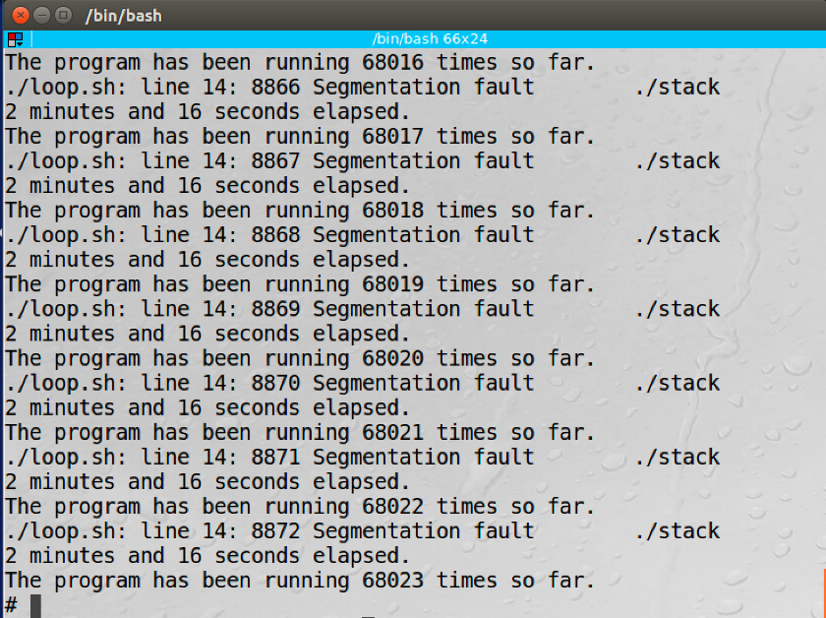
The operation and the result are shown below:

Explanation: The probability of the attack success is 1⁄232 for a 32-bit machine. This operation is not very safe to stop the execution of a malicious. Through repeated execution using the while loop, I successfully attacked and gain root access.

Task 5: Turn on the StackGuard Protection:

The operation is shown below:

Observation: Create a stack program and turn off address settings. Then assemble the system with a usable stack without stack protection. Make the program a set of rooted UID program and create an exploit program to create a bad file. We may find that after performing the stack program, the stack is disconnected.
After that I used gdb to describe this problem, the result is shown below:

Explanation:
Stack guard cam detects that you are in danger of overflowing the bathtub. However in this work the fullness of the buffer is obtained by introducing a local variable before the front indicator of the frame and after the bath. Then keep the value of the variable in place in the pile and give the same value for the vertical or ground variable.
Let’s compare prices before the system is terminated: If prices are different, then a bar overflows occurs and exceeds the local variance value;
If the prices are the same, then the overflow of the bath never happened.
Because it goes on and the value of the local variable is generated by a random generator and will change, we cannot skip the local variable and write only the return address of the stack. Stack Protector works by placing a canary on top of a stack frame when entering work. In addition, if the canary is trampled or not before departure and a certain amount has changed, then the smashing stack is detected and the error is printed, shown in the image above.

Task 6: Turn on the Non-executable Stack Protection:
Observation:
First, I created a stack system and deleted the address randomly. Second, assemble the system without stack protection and create a stack that fails. Next make the program a set of rooted UID program. Then merge and run the exploitation program that created the bad file. We can find in the picture above that there is an error of the partition when the stack system is created and the system is terminated.
After that I used gdb to describe this problem, the result is shown below:

Explanation:
Inactive stack can provide hardware to avoid code (especially Shellcode and binary code in this function) in import from stack. However, it cannot prevent buffer overload from happening because we can get the code elsewhere in the system and fill the buffer. To avoid a return to the libc attack, I find the functionality of the compromised program in the library file and use the risk. Unsuccessful stacks are also a solution for the buffer overflow problem.

